Devki Mahaveer Homoeopathic medical College & Research Hospital
Farathiya , Garhwa, Jharkhand

Extracurricular Activities

2.2.3 | Cultural Activities
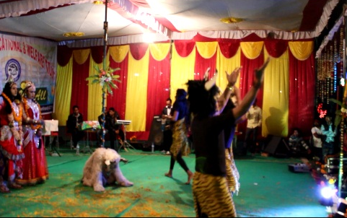
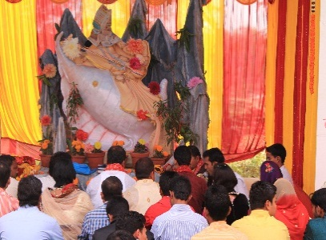
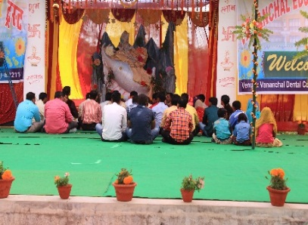

Blood Donation
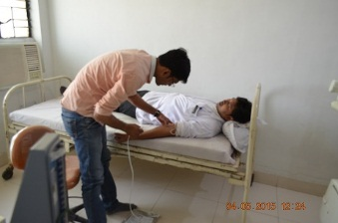
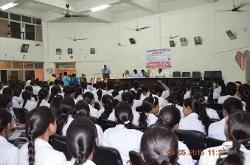
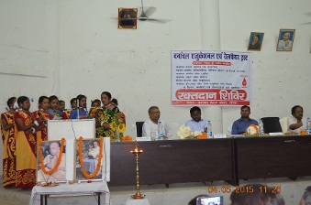
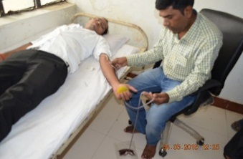

SPORTS ACTIVITIES PHOTOGRAPHS & Hahneman Jayanti
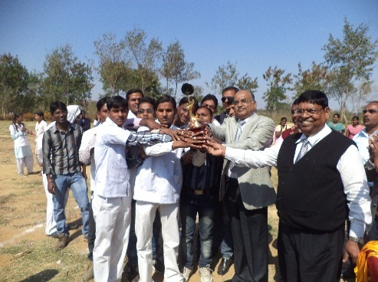
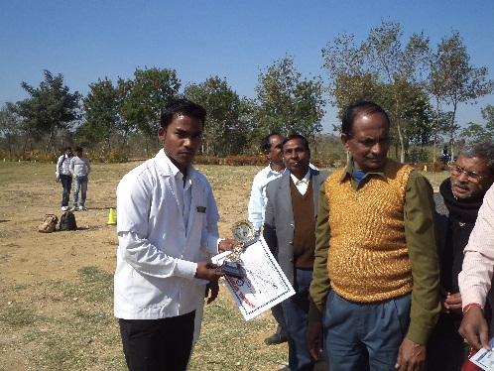
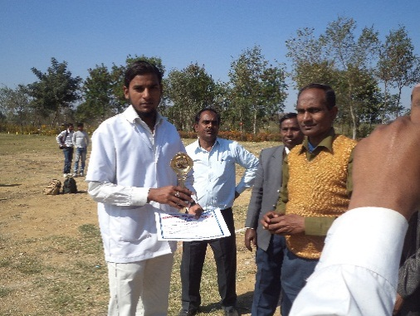
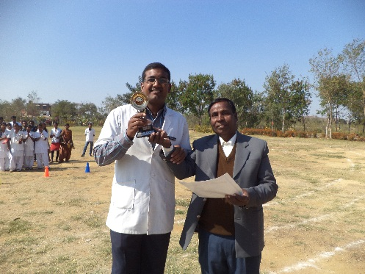
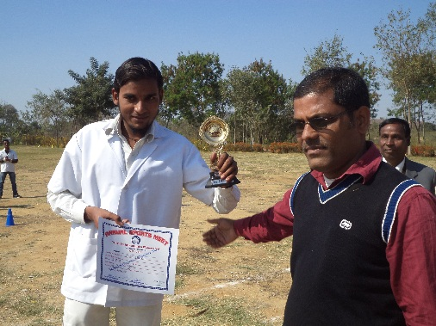
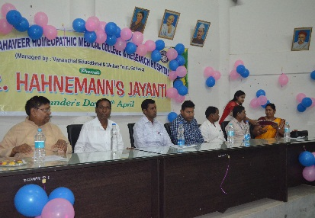
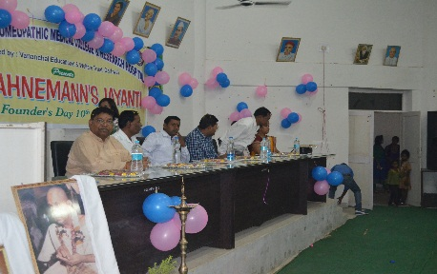
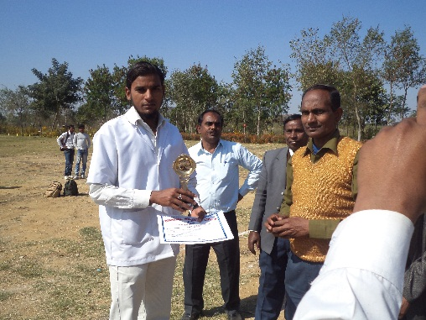

 |  |  |  |  | 4

